Mini Activity 5: Write a program that asks the user for two numbers and adds them

Test Date | What you expect to happen | What happened | Screenshot | How you fixed it | What type of error did you have? Compile, run time or logic?
9/07/2025 | I should get the two numbers from the user added together | I got an error that says “unterminated string literal” | 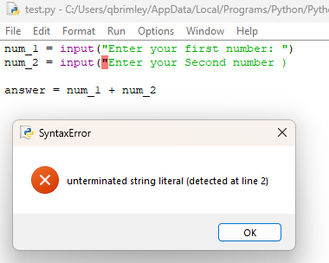 | I added “ to the end of line 2 in my input string | Compile
9/15/2025 | The numbers should have been added together | The numbers just joined together instead | 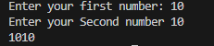 | You need to make the number an integer, so you need to add int before the input | Logic

